City of Saxman/Saxman Seaport
Auto-Pay Autorization Form
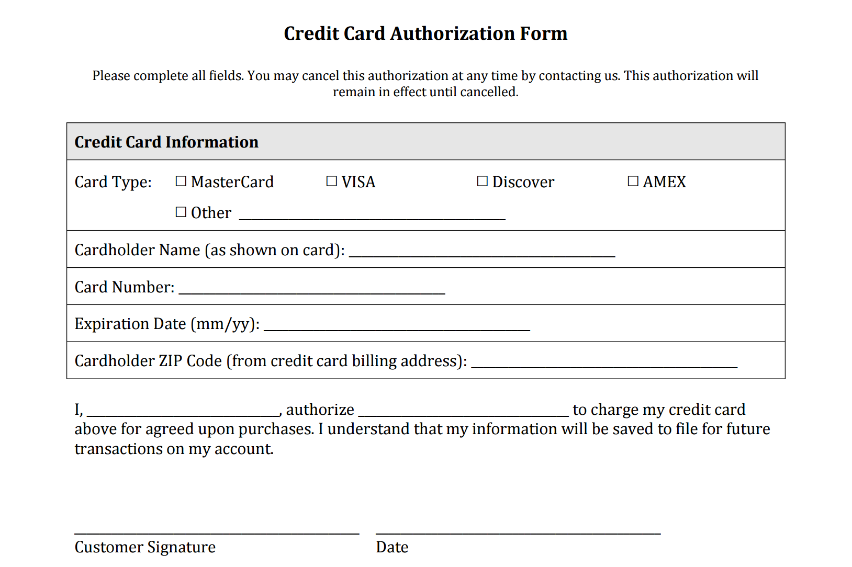

For office use only:
Description of services/monthly billing:

